1. Author Information
Please share:
- Your preferred author name/display name: Sri Lekha Vempati
- A short author bio (100–150 words): Sri Vempati is an author whose writing is inspired by human emotions, relationships, personal growth, and life experiences. Writing and publishing a book had always been one of her dreams, and with the publication of Beyond Rumors, A fictional novel, that dream became a reality. For Sri, becoming a published author is not only an achievement but also the beginning of a journey she hopes to continue through future stories.
- Professional Author photo:
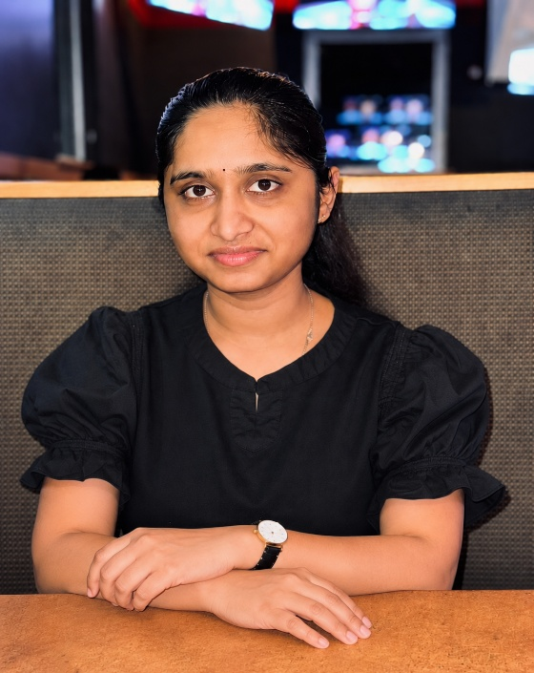
- Your preferred contact email for the website: srilekhavempati1234@gmail.com
- Your location/country, if you would like it displayed publicly: United states

2. Book Information
- Final book title: Beyond the Rumors: The Journey from Innocence to Wisdom
- subtitle: The Journey from Innocence to Wisdom
- Final book cover
- 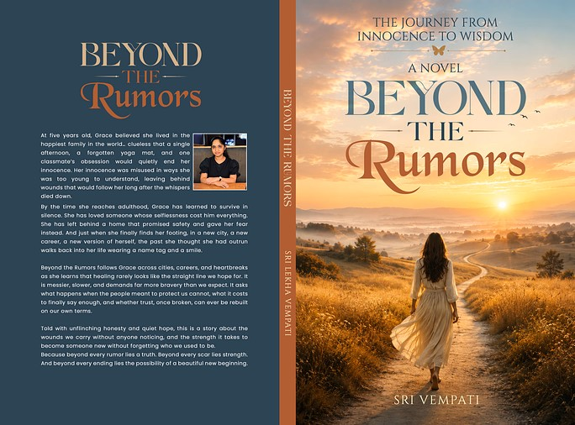

- Book description/blurb:
At five years old, Grace believed she lived in the happiest family in the world… clueless that a single afternoon, a forgotten yoga mat, and one classmate’s obsession would quietly end her innocence. Her innocence was misused in ways she was too young to understand, leaving behind wounds that would follow her long after the whispers died down.
By the time she reaches adulthood, Grace has learned to survive in silence. She has loved someone whose selflessness cost him everything. She has left behind a home that promised safety and gave her fear instead. And just when she finally finds her footing, in a new city, a new career, a new version of herself, the past she thought she had outrun walks back into her life wearing a name tag and a smile.
Beyond the Rumors follows Grace across cities, careers, and heartbreaks as she learns that healing rarely looks like the straight line we hope for. It is messier, slower, and demands far more bravery than we expect. It asks what happens when the people meant to protect us cannot, what it costs to finally say enough, and whether trust, once broken, can ever be rebuilt on our own terms.
Told with unflinching honesty and quiet hope, this is a story about the wounds we carry without anyone noticing, and the strength it takes to become someone new without forgetting who we used to be.
Because beyond every rumor lies a truth. Beyond every scar lies strength. And beyond every ending lies the possibility of a beautiful new beginning.
- Author's note or introduction, if available
- ISBN, if available:
- Publication date: Aug 27, 2026.
- Available formats (eBook, paperback, hardcover, etc.): eBook, Paperback, hardcover
- Purchase links (Amazon, Barnes & Noble, Goodreads, or any other platforms where the book is available):
All the below are United states of America portals
Amazon: https://a.co/d/09p0pnDO
Barnes & Noble: https://www.barnesandnoble.com/w/beyond-the-rumors-sri-lekha- vempati/1151180464?ean=9798902352433
Goodreads: https://www.goodreads.com/book/show/257610588-beyond-the-rumors

3. Social Media & Online Presence
Please share the links/usernames for any existing:
- Instagram account:
Username: Sri_Vempati1
Link: https://www.instagram.com/sri_vempati1?stkn=MXBuejZmMHR0aTI2Ng==

- Facebook page/profile: NA
- Goodreads author/book page: NA
- Amazon Author Central, if available
- Other author or book-related platforms you currently use
4. Your Vision for the Author Brand
A few points from you will help us make the website and content feel authentic to you:
- What would you like readers to know about you as an author?
- What are the main themes/messages you want to communicate through the book?
- Who do you believe is the ideal reader for Beyond the Rumors?
- Are there any authors, websites, or social-media profiles whose style you particularly like?
- Do you have any preferred colors, visual styles, or design preferences?
- Are there any topics, images, or messaging you would prefer us to avoid?

- About me as an author:
Writing a book has always been my dream. I enjoy creating fictional worlds, characters, and emotional stories that entertain readers and leave a meaningful impression.
- Main themes:
Beyond the Rumors is a work of fiction exploring rumors, misunderstandings, relationships, friendship, self-discovery, personal growth, and the journey from innocence to wisdom.
- Ideal readers:
Young adults and adults enjoy emotional, fictional, character-driven stories with relationships, unexpected situations, and life lessons.
- Favorite author/style:
My favorite author is Colleen Hoover. I admire emotionally engaging storytelling while developing my own unique fictional voice and style.
- Design preferences:
Elegant, modern, warm, and slightly mysterious, with a polished fictional-book aesthetic.
- What to avoid:
The branding should not suggest that the story is autobiographical or based on real events or people. Beyond the Rumors is fictional, and I would also like to avoid spoilers, political messaging, and misleading content.

